Electronic Products and Solutions Group

PGU
SPD
Webdoc Version of document:
Author:
Anurag Dhar
Chart Control
Design


Not yet entered

1 Purpose: 2
2 Scope: 2
3 Software Design 2
3.1 High Level Design (Interfaces) 3
3.1.1 IChart Interface 3
3.1.2 IChannelDisplay Interface 4
3.1.3 IAxis interface 4
3.1.4 IDisplaySettings interface 4
3.1.5 IData interface 5
3.1.6 ICustomScale interface 5
3.1.7 IMarkers interface 5
3.2 Detail Level Design (Interfaces and Implementations) 5
3.2.1 IChart Interface and Implementation class 6
3.2.2 IChannelDisplay Interface and Implementation class 8
3.2.3 IAxis interface and Implementation classes 11
3.2.4 IDisplaySettings interface and Implementation class 14
3.2.5 IData interface and Implementation class TraceData 16
3.2.6 IMarkers interface and Implementation class 16
3.2.7 Marker Factory Class 19
3.2.8 Utility Class 19
3.3 Usage and Code Snippet 19
3.3.1 Creating Chart Control 19
3.3.2 Creating and using channel 21
3.3.3 Moving a channel from one chart to other 21
3.3.4 Displaying Data on the channel 21
3.3.5 Changing Display characteristics 21
3.3.6 Adding and Removing a Marker 21

Purpose:
The purpose of this document is to describe the Mirage Chart Control design.

Scope:
The scope of this document is describing the Mirage Chart Control design and usage.

Software Design
This section describes the software architecture.

High Level Design (Interfaces)
This section describes the high level software architecture and the associated responsibility of the blocks. The figure below shows the major parts of the Chart Control design.

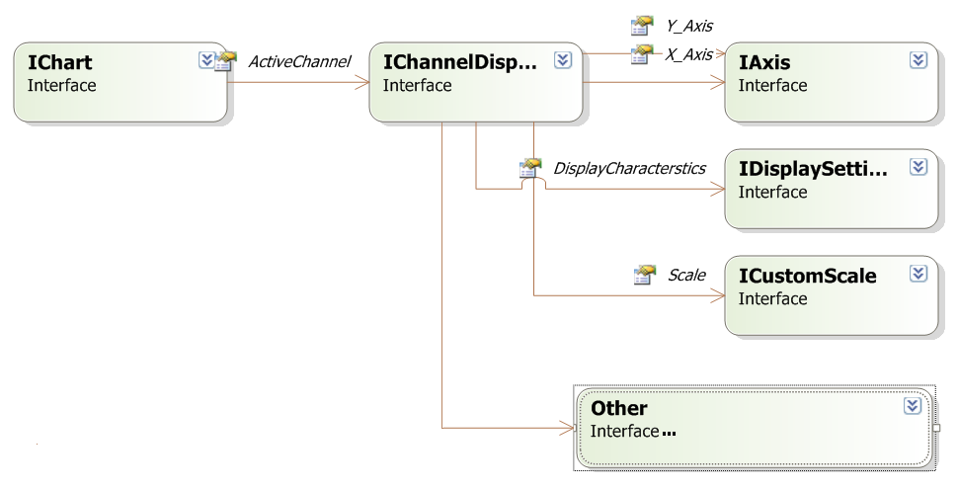

IChart Interface
This Interface represents the visible charting control that user can place on the windows form. The user can attach display of channel data to this Chart. A chart can support display of 0 to N numbers of channel.If a chart contains multiple channels then they will be showed in overlay mode. A chart has one active channel among all channels displayed.

The responsibilities of this Interface will be:
- Provide user with functionality to control the addition and removal of trace display on the chart.
- Selecting a display channel as active display channel.
- Get the total number of channels displayed on the chart at a time.

IChannelDisplay Interface
This interface represents the display of data received from a channel that we want to show for analysis purpose. User can attach/detach the object represented by this interface to any
Chart. IChannelDisplay provides these properties to access various display related characteristics.
X_Axis
Y_Axis
DisplayCharacterstics
Scale
ReSize
SetData(IData oData)

The IChannelDisplay will have the following roles and responsibilities:
- Get data from the user and display it in current display settings of channel
- Provide access and modification to axis related settings.
- Provide access and modification to display related settings
- Provide hook interface of scaling so that user can implement his own scaling mechanism
- Contain the interfaces of axis, scale and other display related characteristics.

IAxis interface
The IAxis interface provides the functionality to modify the axis characteristics of x and y axis. By using this user can set Min, Max, Title text and text color. A channel display will contain the IAxis interface for X as well as Y axis.

The IAxis will have the following roles and responsibilities:
- Set Min and Max value of an axis.
- Set title text of the axis.
- Set text color of the axis.

IDisplaySettings interface
The IDisplaySettings interface contains the characteristics of controlling common display characteristics like current drawing color, background and drawing line width.Each IChannelDisplay will contain one IDisplaySettings.

The IDisplaySettings will have the following roles and responsibilities:
- Provide all common display related settings.
- Immediate visible change in a channel in case display related settings are changed.

IData interface
The IData interface is used to represents the data points that we need to show on the channel.
Object containing implementaion of this interface will be pased to channel to display data points.

ICustomScale interface
The ICustomScale interface provides method ScaleForData. In case user wants to implement his own scaling scheme he must provide implementation to the ICustomScale interface and then attach it to associated channel. The method ScaleForData will be called every time before displaying data on the channel’s chart. This provides the user an opportunity to provide custom scaling as per data set.

The ICustomScale interface will have the following roles and responsibilities:
- Provide methods which user can implement to set his own scaling policy.

IMarkers interface
The IMarkers interface represents collection of markers associated with a channel.User can add and remove markers in a chaaneldisplay. Each IChannelDisplay contains one IMarkers.

The IMarkers interface will have the following roles and responsibilities:
- Provide method to add marker.
- Provide method to remove marker.
- Set a marker as active.

Detail Level Design (Interfaces and Implementations)

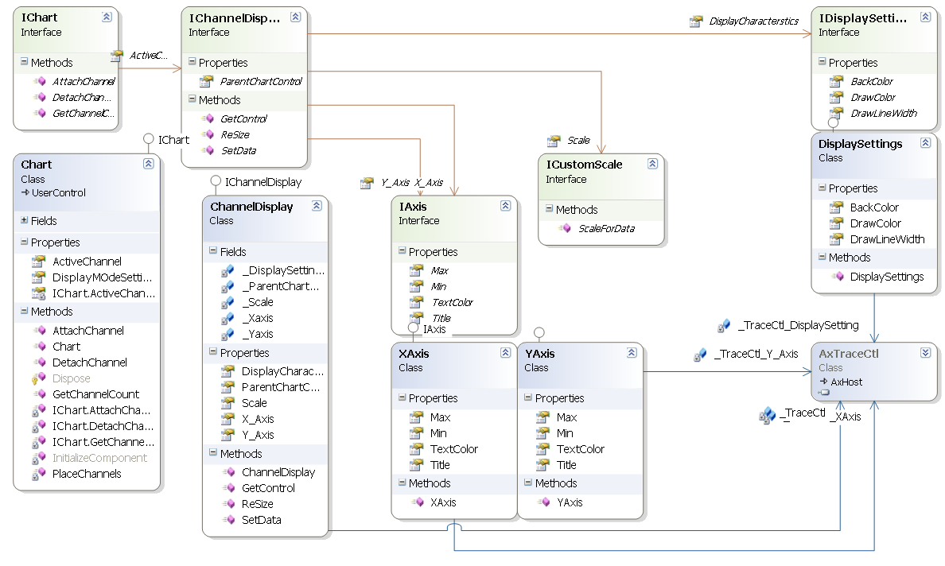

IChart Interface and Implementation class
Chart class is derived from the user control class and implements the IChart interface.
As the Class is derived from User Control it has all the functionality of .net usercontrol. Hence chart can be placed on the form just like any other control and its attributes like size, BackColor, Docking and visibility can be set easily.

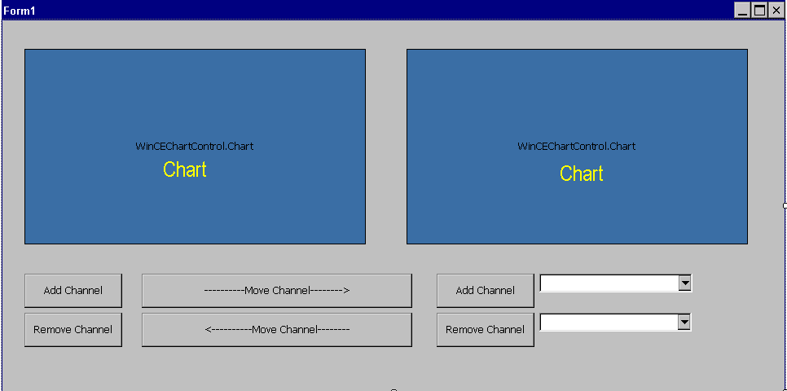

Member Variables:-
- private IChannelDisplay _ActiveChannel;
- private ArrayList _ChannelList = new ArrayList();

- _ActiveChannel

As chart can contain a number of channels, to specify the current active channel a reference to current active channel is maintained in the _ActiveChannel as chart class variable.

- _ChannelList

The chart can have a number of channels attached to it.to keep the references of such channel we have _ChannelList as an array list of IChannelDisplay.

Functions and Properties:-

- public int AttachChannel(IChannelDisplay oChannel)
- public int DetachChannel(IChannelDisplay oChannel)
- public int GetChannelCount()
- public IChannelDisplay ActiveChannel

- public int AttachChannel(IChannelDisplay oChannel)
User will create a channel and then attach that channel to a chart.
In case user’s channel is already attached to one chart,this function will detach it from that chart and attach the channel to itself.
This function will add this channel to the array list _ActiveChannel and resize the channel as per current chart size.

- public int DetachChannel(IChannelDisplay oChannel)
In case user wants to remove a channel from the chart then he can call this function.User does not need to call this function in order to attach the channel to other chart as attach function do that itself.
In side this function the channel is remove the arrarylist _ActiveChannel.

- public int GetChannelCount()
This function gets the current number of channel in the arraylist _ActiveChannel.

- public IChannelDisplay ActiveChannel
This property gets and sets the current active channel in the chart.Setting a channel as active channel brings it on the top of other channels.

IChannelDisplay Interface and Implementation class

ChannelDisplay class implements the interface IChannelDisplay.Along with implementation of IChannelDisplay this class contains a reference to trace control that is initialized in side the constructor.

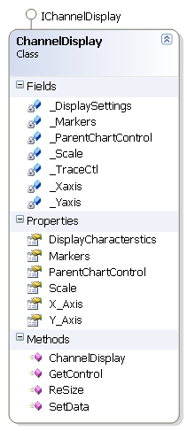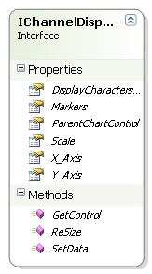

Member Variables:-

private AxAgtTrace.AxTraceCtl _TraceCtl

private IAxis _Xaxis

private IAxis _Yaxis

private IDisplaySettings _DisplaySettings

private ICustomScale _Scale

private IChart _ParentChartControl

private IMarkers _Markers

- private AxAgtTrace.AxTraceCtl _TraceCtl

This is a reference to the trace control.The trace control 2D charting tool developed in C++ and implemented as a activeX control.
The trace control is responcible for displaying all graphs realated drawing.

- private IAxis _Xaxis
This member variable provides functionality to control the stettings of x axis. For more information on this read under XAxis class implementation.This variable is initialised at the time of channel object creation and contains reference to same trace control as the containing object.

- private IAxis _Yaxis
This member variable provides functionality to control the stettings of Y axis. This variable is initialised at the time of channel object creation and contains reference to same trace control as the containing object.For more information on this read under YAxis class implementation.

- private IDisplaySettings _DisplaySettings
This member variable provides functionality to control the display related settings . This variable is initialised at the time of channel object creation and contains reference to same trace control as the containing object.For more information on this read under IDisplaySettings class implementation.

- private ICustomScale _Scale
This member variabel is reference to the user mplementation of scaling.this variable is always checked for null and then its function is called from SetData.

- private IChart _ParentChartControl
This member variabel is reference to the chart that is containing this channel. _ParentChartControl can’t be null If a channel is attached to a chart similarly _ParentChartControl should be Null if channel is not attached to any chart.

- private IMarkers _Markers
This member variabel is a reference to the Markers class object that is contained in this channel.User can not assign this member variable he canonly access it.

Functions and Properties:-

- public void SetData(IData Data)
- public Control GetControl()
- public void ReSize()
- public ICustomScale Scale
- public IAxis X_Axis
- public IAxis Y_Axis
- public IDisplaySettings DisplayCharacterstics
- public IChart ParentChartControl
- public IMarkers Markers

- public void SetData(IData Data)
This method is called by the user to show the data points on the chart.This function calls DataSet function of trace control.This function also calls ScaleForData function of IScale interface implemented by user,this helps user to scale his chart accordingly.

- public Control GetControl()
Get Control function returns the windows control that is used by the channel to draw data points.

- public void ReSize()
ReSize function reset the size and position of the channel to that of its parent container i.e. chart.

- public ICustomScale Scale
Scale is a property which is used to set and retrive the reference to the object implementing IScale interface.

- public IAxis X_Axis
X_Axis is a property which is used to set and retrive the reference to the object containing methods to modify X Axis.

- public IAxis Y_Axis
Y_Axis is a property which is used to set and retrive the reference to the object containing methods to modify Y Axis.

- public IDisplaySettings DisplayCharacterstics
DisplayCharacterstics is a property which is used to set and retrive the reference to the object implementing the IDisplaySetting.

- public IChart ParentChartControl
ParentChartControl is a property which is used to set and retrive the reference to the Container chart of the channel

- public IMarkers Markers
This property returns the reference to the Markers object is a property which is used to retrive the reference to the object implementing the IMarkers

IAxis interface and Implementation classes

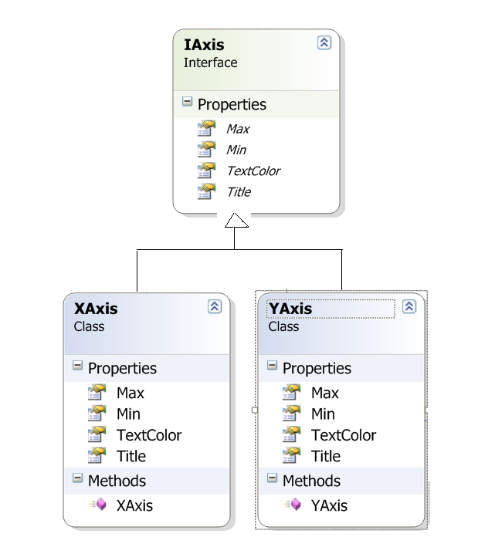

XAxis classes

This class act as a wrapper class on the trace control. All the calls made on the XAxis is forwarded to appropriate function of Trace Control.

Member Variables:-
- private AxAgtTrace.AxTraceCtl _TraceCtl_XAxis

This is a reference to the trace control.The trace control 2D charting tool developed in C++ and implemented as a activeX control.The trace control is responcible for displaying all graphs realated drawing. This Reference is populated from the constructor of the DisplaySettings class.

Functions and Properties:-

- public double Min
- public double Max
- public string Title
- public Color TextColor

- public double Min
This property is used to set the min value of the axis.It sets SclXMin value of the trace control.

- public double Max
This property is used to set the min value of the axis.It sets SclYMax value of the trace control.

- public string Title
This property is used to set the Title string of the axis.It sets Annotation.XTitle value of the
trace control.

- public Color TextColor
This property is used to set the Title string of the axis.It sets AnnXColor value of the trace control.

YAxis classes

This class act as a wrapper class on the trace control. All the calls made on the YAxis is forwarded to appropriate function of Trace Control.

Member Variables:-
- private AxAgtTrace.AxTraceCtl _TraceCtl_YAxis

This is a reference to the trace control.The trace control 2D charting tool developed in C++ and implemented as a activeX control.The trace control is responcible for displaying all graphs realated drawing. This Reference is populated from the constructor of the DisplaySettings class.

Functions and Properties:-

- public double Min
- public double Max
- public string Title
- public Color TextColor

- public double Min
This property is used to set the min value of the axis.It sets SclYMin value of the trace control.

- public double Max
This property is used to set the min value of the axis.It sets SclYMax value of the trace control.

- public string Title
This property is used to set the Title string of the axis.It sets Annotation.YTitle value of the trace control.

- public Color TextColor
This property is used to set the Title string of the axis.It sets AnnYColor value of the trace control.

IDisplaySettings interface and Implementation class

This class act as a wrapper class on the trace control. All the calls made on the DisplaySettings are forwarded to appropriate function of Trace Control.

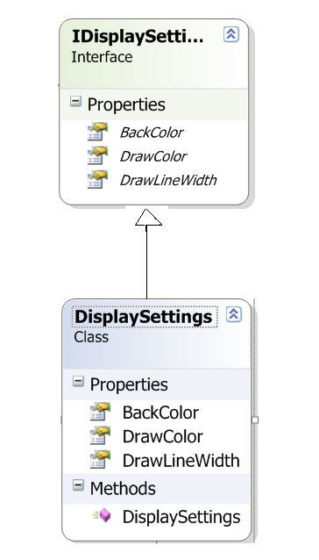

Member Variables:-
- private AxAgtTrace.AxTraceCtl _TraceCtl_DisplaySetting
This is a reference to the trace control.The trace control 2D charting tool developed in C++ and implemented as a activeX control.The trace control is responcible for displaying all graphs realated drawing.This Reference is populated from the constructor of the DisplaySettings class.

Functions and Properties:-
- public Color DrawColor
- public Color BackColor
- public float DrawLineWidth

- public Color DrawColor
This property is used to set the Draw Color of the channel.It sets DrawColor value of the trace control.It also uses the Utility class to convert C# color type to C++ uint.

- public Color BackColor
This property is used to set the Background Color of the channel.It sets BackColor value of the trace control.

- public float DrawLineWidth
This property is used to set the Line Width of the channel.It sets DrawLineWidth value of the trace control.

IData interface and Implementation class TraceData
TraceData class is implementing the IData interface.

Member Variables:-
- private Double [] _dArray
This is a an array representing the data points that we need to display on channel display.its value and size is set at the time of object creation i.e. constructor.

Functions and Properties:-
- public double [] DataPoints
This property is used to get or set the array of Datapoints.

IMarkers interface and Implementation class

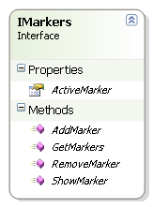

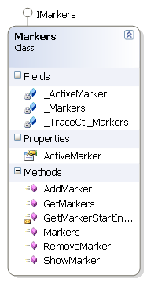

Member Variables:-
- private AxAgtTrace.AxTraceCtl _TraceCtl_Markers
- private ArrayList _Markers
- private IMarker _ActiveMarker

- private AxAgtTrace.AxTraceCtl _TraceCtl_Markers

This is a reference to the trace control.The trace control 2D charting tool developed in C++ and implemented as a activeX control.The trace control is responcible for displaying all graphs realated drawing.This Reference is populated from the constructor of the DisplaySettings class.

- private ArrayList _Markers
_Markers is a reference to the collection of objects implementing IMarker.This list is update every time we add or remove a marker.

- private IMarker _ActiveMarkes
This is a reference to the objects implementing IMarker.This represets the marker which is currently active.The user can move or change display characterstics of the currently active marker.

Functions and Properties:-
- public ArrayList GetMarkers()
- public IMarker AddMarker(eMarkerType oMarkerType)
- public void RemoveMarker(IMarker oMarkerToRemove)
- public IMarker ActiveMarker
- internal int GetMarkerStartIndex(IMarker oMarker)

- public ArrayList GetMarkers()
This function returns the Marker collection containing current markers .

- public IMarker AddMarker(eMarkerType oMarkerType)
AddMarker creates a marker of given type and then add it to the _Markers ArrayList.If curently no active marker is selected then the created marker is set as active marker.

- public void RemoveMarker(IMarker oMarkerToRemove)
RemoveMarker removes a given marker from a channel.It checks if the given marker is current acti ve marker then the next marker is set as the active marker

- IMarker ActiveMarker
This property is used to set and get the active marker.

- internal int GetMarkerStartIndex(IMarker oMarker)

This function is used to map a marker object in ChartControl to the Marker index in the Trace control.

Marker Factory Class

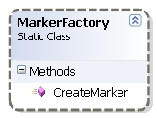

Maker factory is a static class used as a factory to create markers.It has a ststic function CreateMarker which returns the Imarker interface of the Marker object created.The use of MarkerFactory class seperates the Marker creation mechanism from its behavioural code.

Utility Class

Utility class is a static class.This class contains common services,conversion utility which are not dependent on the client.This class has been made static as it does not have any state.This class contains only static functions.

Functions:-
- public static int ColorToInt (System.Drawing.Color c)
- public static Color IntToColor (int UintColor)

- public static int ColorToInt (System.Drawing.Color c)
This function is used to convert the System.Drawing.Color to its integer representation.

- public static Color IntToColor (int UintColor)
This function is used to convert the integer to the System.Drawing.Color representation.

Usage and Code Snippet

Creating Chart Control
As chart control is derived from the UserControl it can be used like other common control as buttons,TextBox etc.Drag and drop the WinCeChartControl.Dll on the toolbox.
The chart control will be added in the toolbar.
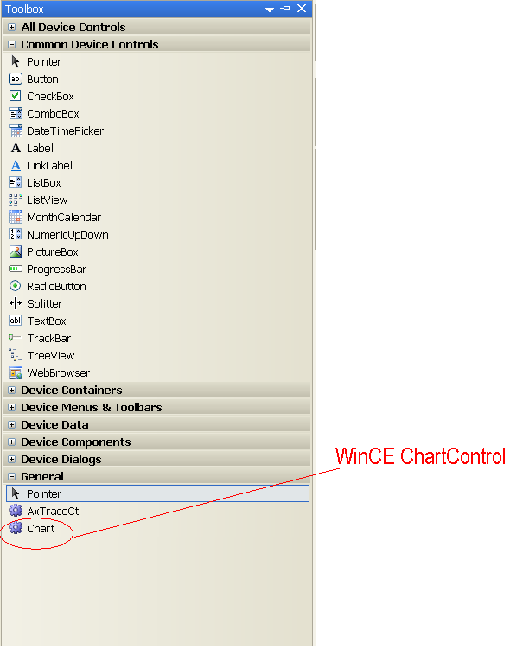

Now you can use this control in your form.

Creating and using channel

The below code shows how to create and attach a channel to a chart named as ChartObject.

IChannelDisplay Channel = new Channel();//create
ChartObject.AttachChannel(Channel);//Attach to chart

Moving a channel from one chart to other
The below code shows how to move one channel from one chart to other chart .

IChannelDisplay Channel1 = new Channel();
ChartObject1.AttachChannel(Channel); //attach with first chart
//attach with second chart
ChartObject2.AttachChannel(Channel); //this will automatically detach from the ChartObject1 and attach to the ChartObject2

Displaying Data on the channel
IChannelDisplay Channel = new Channel();//create
ChartObject.AttachChannel(Channel);//Attach to chart
The data on the channel can be set by
double[] d_Array = new double[100];
//populate d_Array with meaningfull values
IData data = new TraceData(d_Array);
Channel.SetData(data);//this will display data points on the channel

Changing Display characteristics
The below code shows how to modify the display attributes of channel
IChannelDisplay Channel = new Channel();
ChartObject.AttachChannel(Channel);
set the draw color of a channel :-
Channel.DisplayCharacterstics.DrawColor = Color.Red;

Adding and Removing a Marker
The below code adds a marker in the chart chart1 ‘s active channel .
IMarker IM = chart1.ActiveChannel.Markers.AddMarker(eMarkerType.eSinglePointMarker);
//Adds a marker

chart1.ActiveChannel.Markers.RemoveMarker(IM);
//Removes a marker

